**DAILY ONLINE ACTIVITIES SUMMARY**

|  |  |  |  |  |  |  |  |
| --- | --- | --- | --- | --- | --- | --- | --- |
| **Date:** | **16 June 2020** | | | | **Name:** | **KHATHEEJA SAFREENA.** | |
| **Sem & Sec** | **4th sem, 2nd year** | | | | **USN:** | **4AL18CS037.** | |
| **Online Test Summary** | | | | | | | |
| **Subject** | | **COMPLEX ANALYSIS AND STATISTICAL METHOD.** | | | | | |
| **Max. Marks** | | **30** | | **Score** | | **18** | |
| **Certification Course Summary** | | | | | | | |
| **Course** | **INTRODUCTION TO INFORMATION SECURITY.** | | | | | | |
| **Certificate Provider** | | | **GreatLearning** | **Duration** | | | **6 hours** |
| **Coding Challenges** | | | | | | | |
| **Problem Statement: 1)** Write a C Program to implement the Binary Reversal.  2) Write a Python program to check whether a given a binary tree is a valid binary search tree (BST) or not? | | | | | | | |
| **Status: Executed** | | | | | | | |
| **Uploaded the report in Github** | | | | **Yes** | | | |
| **If yes Repository name** | | | | **[http://shafreenasharief / lockdown-coding](http://shafreenasharief / lockdown-coding" \o "http://shafreenasharief / lockdown-coding)**  **[http://shafreenasharief / locked-down--certification-course](http://shafreenasharief / locked-down--certification-course" \o "http://shafreenasharief / locked-down--certification-course)**  **[http://shafreenasharief / Daily\_Report](http://shafreenasharief / Daily_Report" \o "http://shafreenasharief / Daily_Report)** | | | |
| **Uploaded the report in slack** | | | | **Yes** | | | |

Online Test Details: (Attach the snapshot and briefly write the report for the same)

Certification Course Details: (Attach the snapshot and briefly write the report for the same)

Coding Challenges Details: (Attach the snapshot and briefly write the report for the same)

**ONLINE TEST SUMMARY**

ONLINE TEST ON **COMPLEX ANALYSIS AND STATISTICAL METHOD(18MAT41)** Was conducted on 16/06/2020 from 3:00 pm to 3:40 min with time limit of 40 min. There were 15 question in total and each question consist of 2 marks each. And the marks that I scored is 18/30

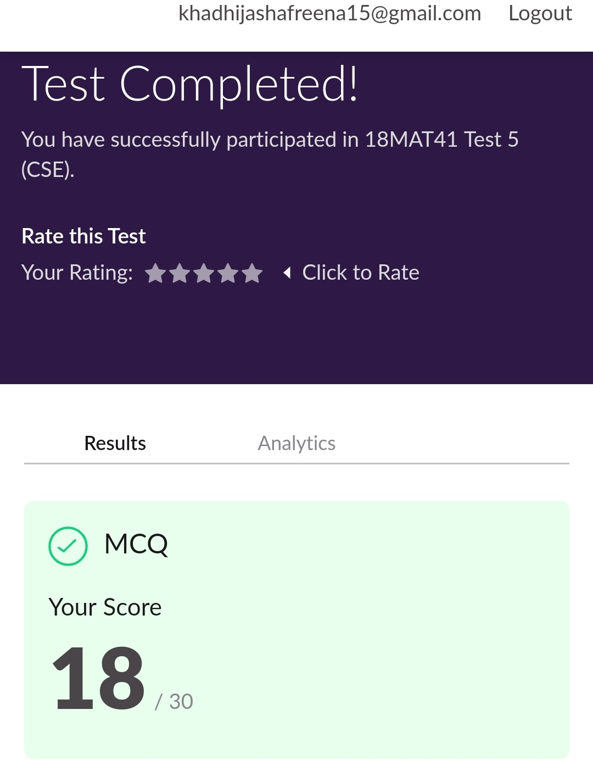

**CERTIFICATION COURSE SUMMARY:**

Today I started new course **INTRODUCTION TO INFORMATION SECURITY** through **GREAT LEARNING** the course is secluded for 6hrs. After the completion of course, certificate will be provided. I completed all the module .I attempted quiz ,which gave me a clear veiw about the topics that were thought and discussed.It consists of 7 modules which also include assessments.

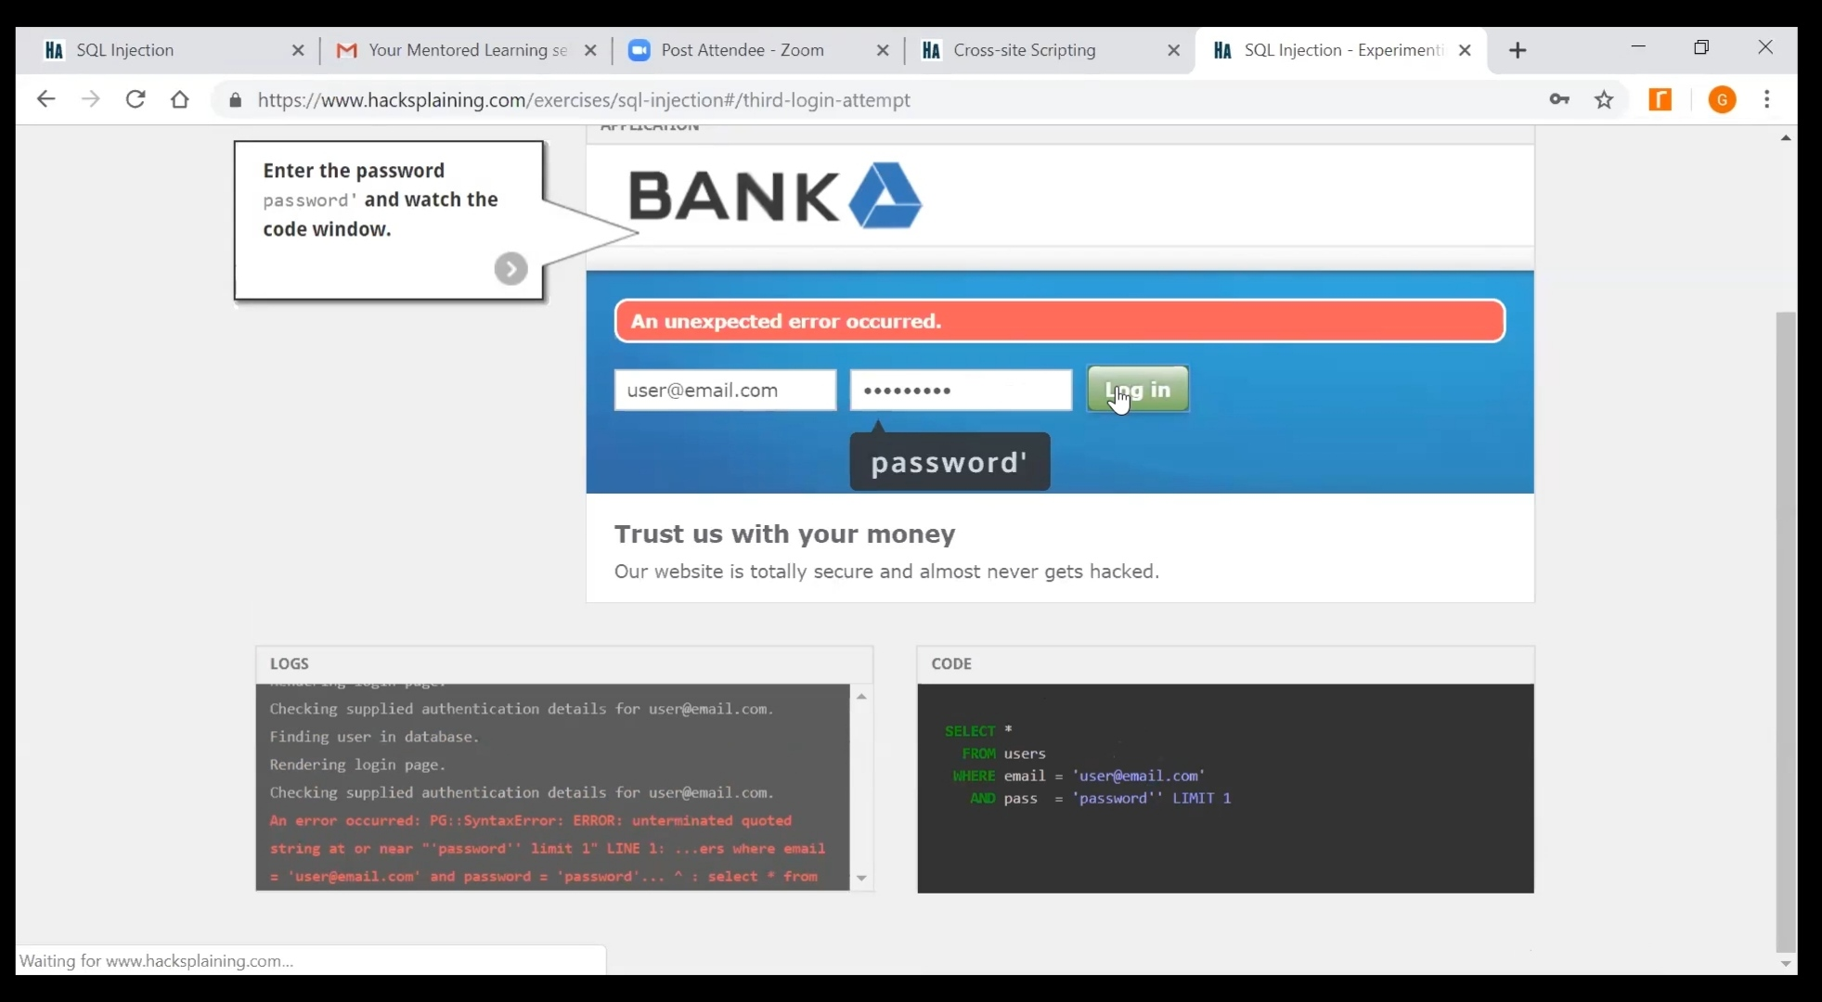

**CODING CHALLENGES**

Today I solved 2 coding challenge,

1. **Write a Python program to check whether a given a binary tree is a valid binary search tree (BST) or not?**

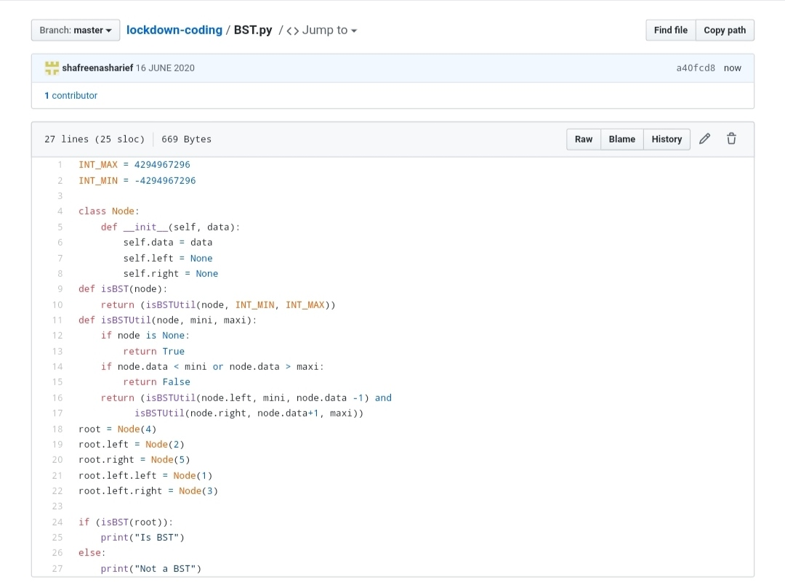

**2.Write a C Program to implement the Binary Reversal.**

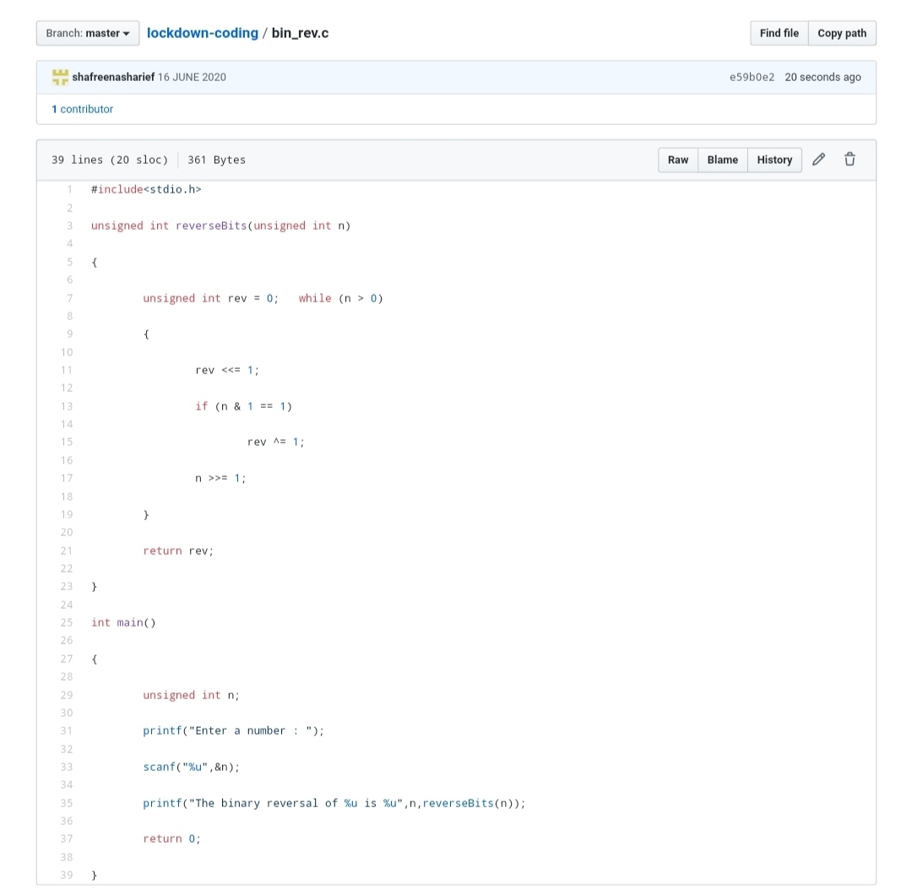

**SOLUTION :** I have uploaded the solution of the above 3 coding problems in my GitHub repository.

[http://shafreenasharief / lockdown-coding](http://shafreenasharief / lockdown-coding" \o "http://shafreenasharief / lockdown-coding)

[http://shafreenasharief / locked-down--certification-course](http://shafreenasharief / locked-down--certification-course" \o "http://shafreenasharief / locked-down--certification-course)

[http://shafreenasharief / Daily\_Report](http://shafreenasharief / Daily_Report" \o "http://shafreenasharief / Daily_Report)